Warm Up

- Jumping Jacks x10
- Squat & Hold x10
- Knee Hug to Lunge 2x10 yd (jog out for 10 yd)
- Russian Kicks 2x10 yd (jog out for 10 yd)
- Walking Quad Stretch (Ankle Grabs) 2x10 (jog out for 10 yd)
- Inchworm Push Up 2x10 (jog out for 10 yd)
- A-Walk 2x10 yd (jog out for 10 yd)
- A-Skip 2x10 yd (jog out for 10 yd)
- High Knees 2x10 yd (jog out for 10 yd)
- . High Knee Butt Kick 2x10 yd (jog out for 10 yd)

Quick Feet

- Two Feet Side to Side 3x10 sec.
- Two Feet Front to Back 3x10 sec.
- Single Leg Side to Side 3x10 sec.
- Single Leg Front to Back 3x10 sec.

Agilities & Conditioning
Weeks 1-8

MONDAY | TUESDAY | THURSDAY | FRIDAY
- Warm Up  - 2 Cone Agilities x2 each way  - Sprint-Sprint  - Sprint-Backpedal  - Backpedal-Sprint  - Figure 8  - 5x10 yd Sprint (walk back rest)  - 1-minute rest  - **4x20 yd Sprint (walk back rest)  - 1-minute rest  - Stretch  ** Add two reps every 3 weeks  Week 1-3 – 4 reps  Week 4-6 – 6 reps  Week 7-8 – 8 reps | - Warm Up  - Plyometric Video  https://www.youtube.com/watch?v=CzEFtonkXsA  - 4x20 yd for each exercise  - Stretch | - Warm Up  - 5-5-10 x2 each way  Week 1-2 – Pattern 1  Week 3-4 – Pattern 2  Week 5-6 – Pattern 3  Week 7-8 – Pattern 4  - 5-10-5 Shuttle x2 each way  - 6-10 30 yd Sprint  - Full Speed  - 1-minute rest  - Stretch | - Warm Up  - Plyometric Video  https://www.youtube.com/watch?v=CzEFtonkXsA  - 4x20 yd for each exercise  - Stretch

2 Cone Agilities – 2 Reps Each Way

5-5-10 Line Drills – 2 Reps Each Way
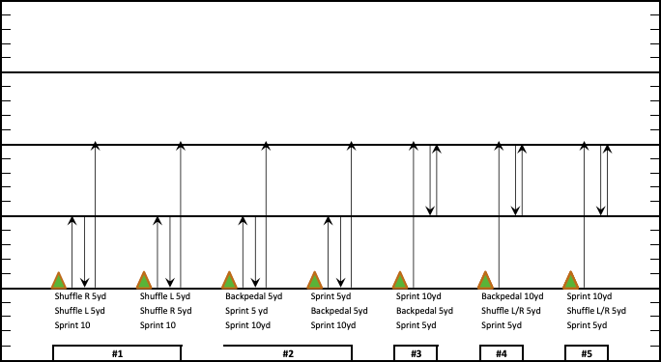
5-10-5 Shuttle – 2 Reps Each Way

